PROJECT REPORT
AI LANGUAGE TRANSLATION TOOL

Submitted for: CodeAlpha Artificial Intelligence Internship

Submitted By
- Name: narsipuram pravallika
- College Name: vignan’s institute of engineering for women
- Internship Domain: Artificial Intelligence
- Project Title: AI Language Translation Tool
- Submission Date: 13-5-2026

1️⃣ Introduction
Artificial Intelligence is transforming the way people communicate across different languages. Language barriers often create difficulties in communication, education, business, and travel. To solve this issue, an AI-powered Language Translation Tool has been developed.
This project allows users to translate text from one language to another instantly using Artificial Intelligence techniques and translation APIs. The application provides a simple, attractive, and user-friendly interface where users can enter text, select languages, and receive translated output in real time.
The project was developed as part of the CodeAlpha Artificial Intelligence Internship program.

2️⃣ Objectives
The main objectives of this project are:

- To develop a real-time language translation system.
- To provide an attractive and professional user interface.
- To reduce language communication barriers.
- To implement AI-based translation using APIs.
- To create a simple and easy-to-use application.
- To gain practical experience in Artificial Intelligence and NLP.

3️⃣ Problem Statement
People around the world speak different languages, making communication difficult in many situations. Manual translation takes time and may not always be accurate. Therefore, there is a need for an automated language translation system that can quickly and accurately translate text between multiple languages.
This project aims to solve this problem by building an AI-based translation tool that provides fast and efficient translations.

4️⃣ Technologies Used
Technology | Purpose
Python | Backend Programming
Streamlit | Frontend User Interface
Googletrans API | Language Translation
HTML/CSS | Styling and Design
VS Code | Development Environment
5️⃣ System Requirements
Hardware Requirements
- Processor: Intel i3 or above
- RAM: 4GB minimum
- Storage: 1GB free space
- Software Requirements
- Python 3.10+
- VS Code
- Streamlit
- Googletrans Library
- Internet Connection
6️⃣ Project Architecture
User Input
↓
Frontend UI (Streamlit)
↓
Translation API Processing
↓
Translated Output
↓
Display Result to User
7️⃣ Methodology
The following methodology was used to develop the project:
- Requirement Analysis
- Designing User Interface
- Installing Required Libraries
- Integrating Translation API
- Implementing Translation Logic
- Testing the Application
- Deploying and Documenting the Project

8️⃣ Implementation
The project was implemented using Python and Streamlit.
Step 1 — User Input
The user enters text into the application.
Step 2 — Language Selection
The user selects source and target languages.
Step 3 — Translation Process
The entered text is sent to the Google Translate API.
Step 4 — Display Output
The translated result is displayed on the screen.
Step 5 — Copy Functionality
Users can copy the translated text using the copy button.

9️⃣ Features of the Project
✅ Real-Time Translation
✅ Multiple Language Support
✅ Professional User Interface
✅ Copy Translation Feature
✅ Fast Processing Speed
✅ Error Handling
✅ User-Friendly Design

🔟 Screenshots
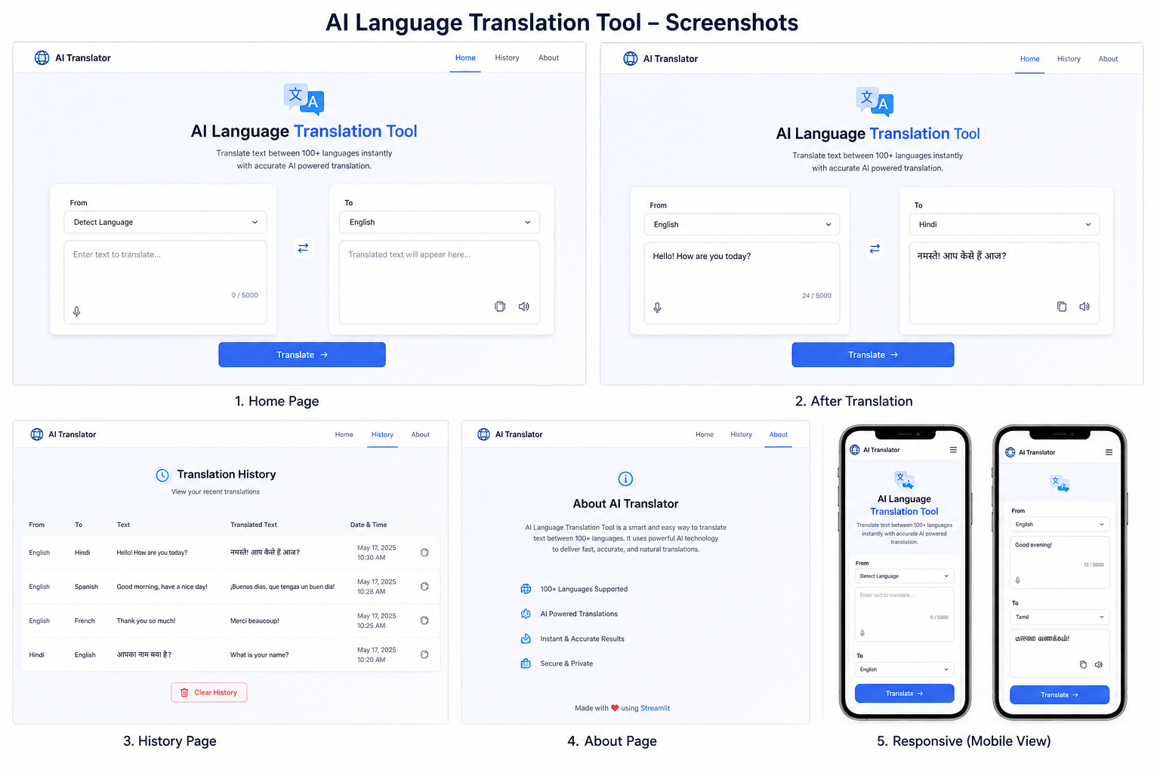

1️⃣1️⃣ Advantages
- Easy to use
- Saves time
- Supports multiple languages
- Improves communication
- Attractive and responsive interface
- Fast translation process

1️⃣2️⃣ Challenges Faced
During development, several challenges were faced:
- Handling API errors
- Designing a responsive UI
- Managing package compatibility
- Improving translation speed
These challenges were solved through debugging and testing.

1️⃣3️⃣ Future Enhancements
The following features can be added in future versions:
- Voice Input Translation
- Text-to-Speech Feature
- Dark Mode
- Translation History
- Download Translation as PDF
- Mobile Application Version

1️⃣4️⃣ Conclusion
The AI Language Translation Tool was successfully developed using Python and Streamlit. The application provides real-time language translation with a modern and user-friendly interface.
This project helped in understanding Artificial Intelligence concepts, Natural Language Processing, API integration, and frontend design.
The project fulfills all the objectives and demonstrates the practical application of AI in real-world communication.

1️⃣5️⃣ References
- Python Official Documentation
- Streamlit Documentation
- Google Translate API Documentation
- CodeAlpha Internship Guidelines

